***DAY 2 PLANNING THE TECHNICAL FOUNDATION***

**user**

 **A "user" is a person who utilizes a system or**



**Next.js is a React framework for building fast and scalable web applications**.

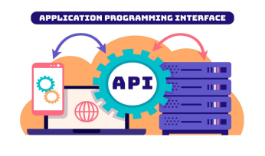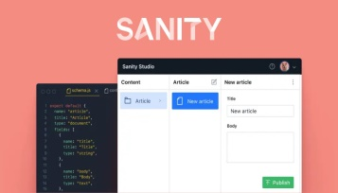

An API is a set of protocols that enables software applications to interact.

Sanity CMS is a headless content management system for structured content.

**Payment  
Gateway**

**Shipment  
Tracking API**

A Payment Gateway authorizes and processes online payments.

A Shipment Tracking API provides real-time updates on shipment status and location.